{{DATE}}

**{{CLIENT_NAME}}**

**{{ADDRESS}}**

**ATTENTION: {{CONTACT_PERSON}}**

Dear Sir/Madam,  
  
We take special pleasure in submitting our firm quotation for the KYOCERA DIGITAL COPIER ECOSYS MA4500X as follows:

**BLACK ‘n WHITE COPY & PRINT, COLORED SCAN**

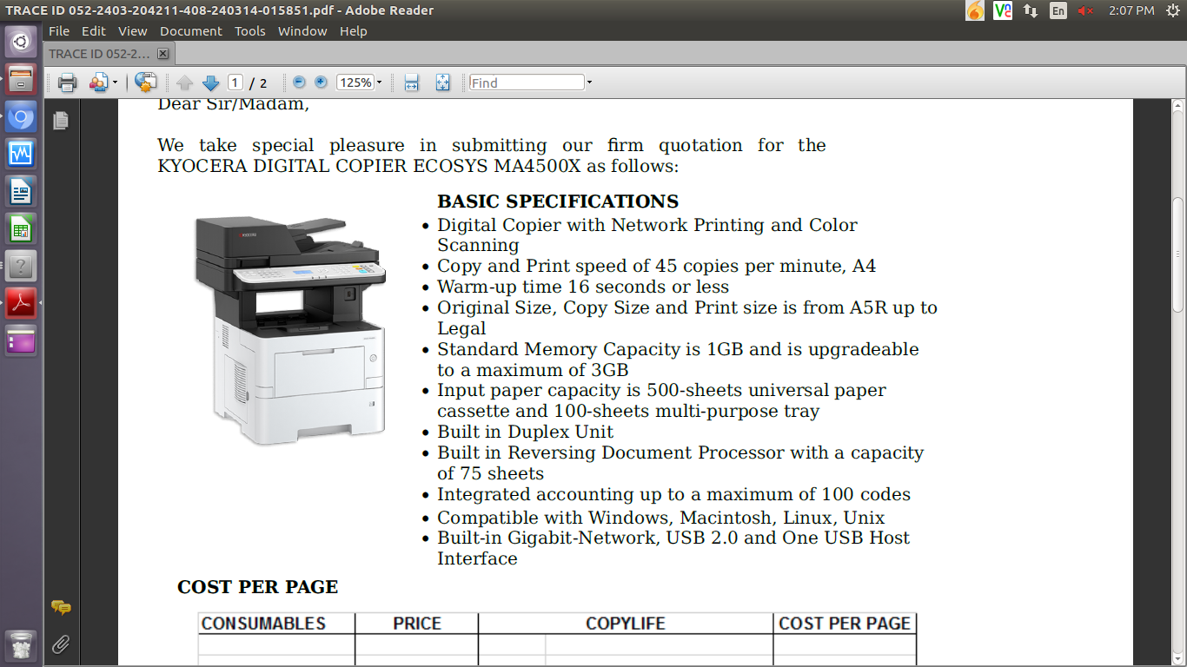

* **PRICE OF MACHINE & ACCESSORIES:**

|  |  |  |
| --- | --- | --- |
| 1 unit of KYOCERA DIGITAL COPIER ECOSYS MA4500X | Php | 126,000.00 |

**PROMO PRICE**

MACHINE ORIGINAL PRICE: Php 126,000.00

LESS PROMO DISCOUNT Php 30,000.00

**TOTAL DISCOUNTED AMOUNT PHP 96,000.00(LESS 10% IF CASH = PHP 86,400.00)**

Php 8,000/MO. FOR 12 MOS. (CREDIT CARD)

* **OPTIONAL/ACCESSORIES (NOT INCLUDED IN THE MACHINE PRICE)**

WIFI/WIRELESS LAN Php 8,000.00

ADD’L 3 YEARS SERVICE WARRANTY EXT Php 8,400.00 (TOTAL 5 YEARS)

STEEL TABLE/CABINET/PEDESTAL Php 6,700.00

* 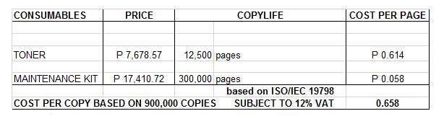**PRICE OF CONSUMABLES**

**Terms of Payment:** COD/ 30 DAYS  
  
**VALIDITY:** Prices are subject to change without prior notice, please confirm with us before finalization of the order.  
  
**WARRANTY:**   
  
KYOCERA DIGITAL PLAIN PAPER COPIERS are guaranteed spare parts replacement FREE OF CHARGE for ONE (1) year, or up to 300,000 copies/print whichever comes first.  
  
Warranty for accessories and options is ONE (1) year from the date of delivery.  
  
We also assure prompt service whenever you need assistance. Repair service is FREE for TWO (2) years. Should our machine require prolonged service, we shall install a backup unit immediately for your convenience.  
  
Installation and Training of Personnel: Our expert service engineers install all our machines and they will be glad to train interested personnel on the detailed mechanics of the machine free of charge.  
  
Moreover, the amount quoted above excludes the cost of any required tests or medical certifications such as, but not limited to Rapid tests, Antigen tests, and RT-PCR tests. The actual cost will be billed separately

We are looking forward to hearing from you soon. For any questions or concerns, please feel free to call us at 7618-0274.  
  
  
Very truly yours, Conforme:

**JAYPEE V. SONIEL __________________________________**  
SENIOR ACCOUNT EXECUTIVE II

09176240820 (Viber Ready)